Manage IPv6 Networking
What is an IP Address?
An IP address is a unique number given to a device so it can:
- Identify itself
- Communicate on a network
Example:
- IPv4 → 192.168.1.10
- IPv6 → 2001:db8::10

What is IPv6?
IPv6 (Internet Protocol version 6) is the new version of IP, created to replace IPv4.
Official global launch: June 6, 2012 (World IPv6 Launch)

🔹Why IPv6 is Needed? (Explain to Students)
IPv4 | IPv6
32-bit address | 128-bit address
Limited IPs | Unlimited IPs
Uses broadcast | No broadcast
Example: 192.168.1.1 | Example: 2001:db8::1

🔹 IPv6 Address Format (Easy)
- Written in hexadecimal
- Uses colon (:)
- 8 blocks (each 16 bits)
Full IPv6:
2001:0db8:0000:0042:0000:8a2e:0370:7334

🧪 PRACTICAL: Configure IPv6 on RHEL (STEP-BY-STEP)

🔸 Step 1: Check Network Interface
ifconfig
(or)
ip a
📌 Note interface name (example: ens160)
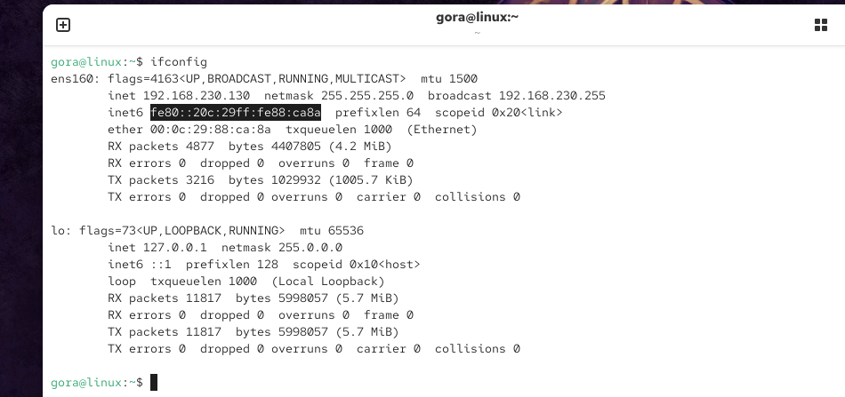

🔸 Step 2: Test IPv6 Connectivity (Before Config)
ping ab07:123:456:789:0abc::def

It will fail (no IPv6 configured yet)
This is good for teaching comparison.

🔸 Step 3: Show Network Connections
nmcli connection show
📌 You will see something like:
ens160
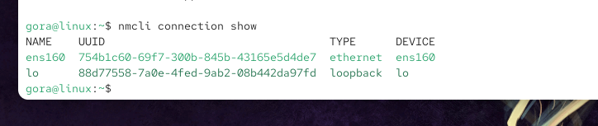

🔸 Step 4: Clone Existing Connection
(We don’t touch original connection)
sudo nmcli connection clone ens160 test1
📌 test1 = new IPv6 connection

🔸 Step 5: Verify New Connection
nmcli connection show

🔸 Step 6: Assign IPv6 Address & Gateway
sudo nmcli connection modify test1 ipv6.addresses ab07:123:456:789:0abc::def/64 gw6 ab07:123:456:789:0abc::1
Explain to Students:
- /64 → IPv6 subnet
- gw6 → IPv6 gateway
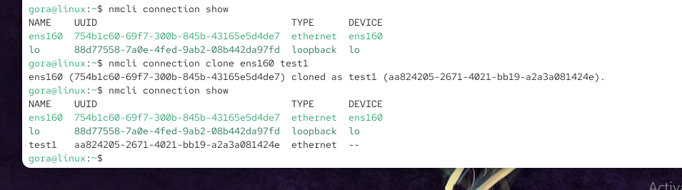

🔸 Step 7: Set IPv6 Method to Manual
sudo nmcli connection modify test1 ipv6.method manual

🔸 Step 8: Enable Auto-Connect
sudo nmcli connection modify test1 connection.autoconnect yes

🔸 Step 9: Reload Network Manager
sudo nmcli connection reload

🔸 Step 10: Activate New IPv6 Connection
sudo nmcli connection up test1
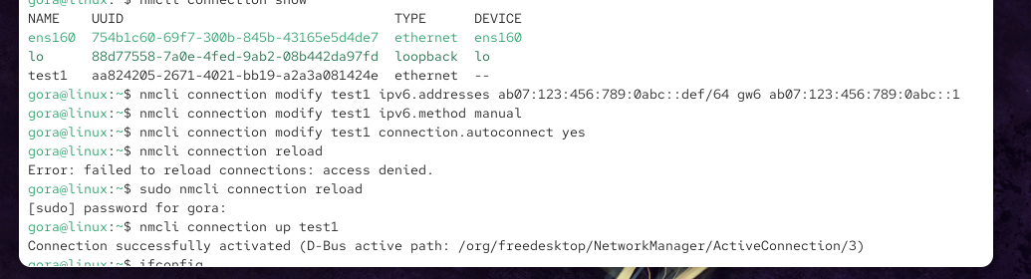

🔸 Step 11: Verify IPv6 Address
ifconfig
(or)
ip -6 a
👉 You should see:
ab07:123:456:789:0abc::def
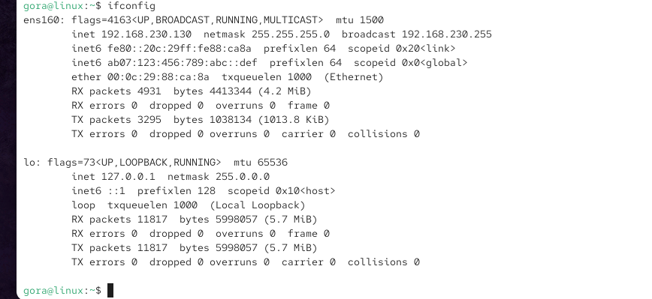

🔸 Step 12: Test IPv6 Connectivity (After Config)
ping ab07:123:456:789:0abc::def
✅ Success = IPv6 Working

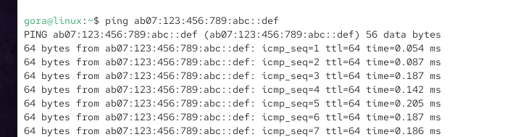

How to Make Network Back to DEFAULT (Undo IPv6 Lab)
You did this earlier:
- Cloned ens160 → test1
- Added manual IPv6
- Activated test1
Now we will restore the original/default connection.

METHOD 1 (BEST & SIMPLE – RECOMMENDED FOR STUDENTS)
Step 1️⃣ Bring down the IPv6 test connection
nmcli connection down test1
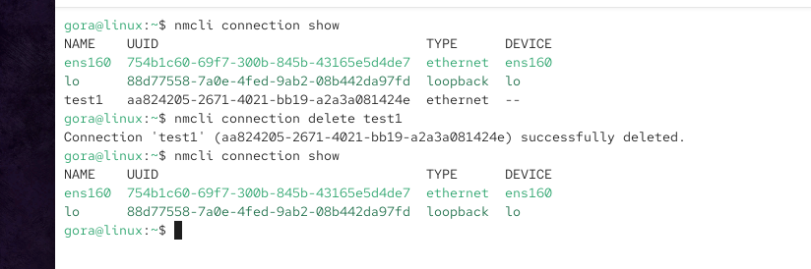

Step 2️⃣ Bring up the original default connection
nmcli connection up ens160
(ens160 may be eth0, ens33, etc. — use your original one)

Step 3️⃣ Verify
ip a
IPv6 manual address will be gone
System is back to default network

METHOD 2: Delete the IPv6 Test Connection (CLEAN WAY)
If you don’t need test1 anymore, delete it.
Step 1️⃣ Delete test connection
nmcli connection delete test1

Step 2️⃣ Restart NetworkManager (optional but clean)
systemctl restart NetworkManager
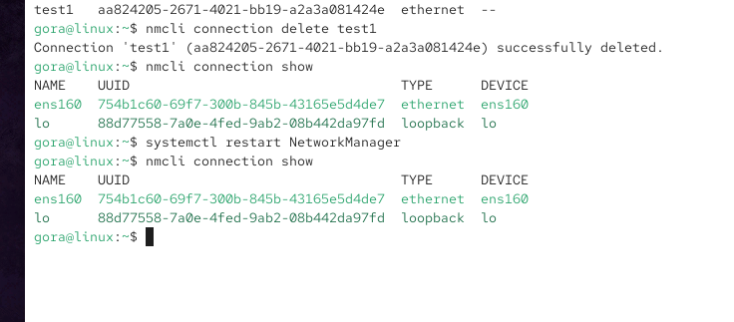

Step 3️⃣ Check connections
nmcli connection show
Only default connection remains

METHOD 3: Reset IPv6 Settings on test1 (Advanced)
If you want to keep test1 but remove IPv6 manual config:
nmcli connection modify test1 ipv6.method auto
nmcli connection modify test1 ipv6.addresses ""
nmcli connection down test1
nmcli connection up test1

